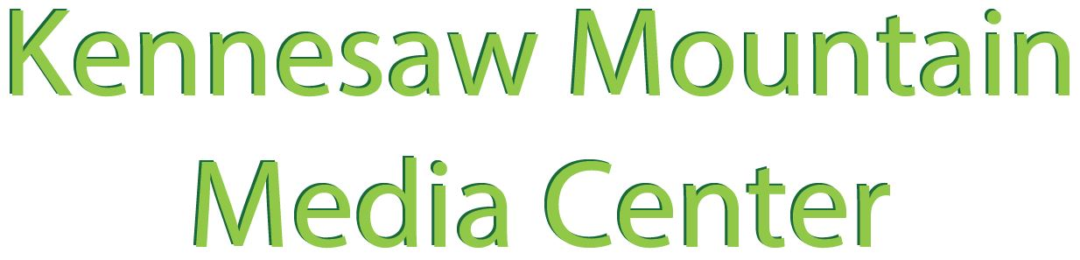

Student Aide Final Reflection

We appreciate all of the work that you have contributed to assist patrons, organize resources, maintain and enhance our space to create a welcoming environment that supports learning and personal growth. Strong communication skills are important to success in most jobs and careers, so we hope that the reflections that you have completed throughout the semester will strengthen your ability to communicate the work experience and skills that you gained while serving in the media center.
For your final reflection as a KMH Media Center Student Aide, please give specific examples with descriptive details as you respond to each of the prompts below.

- Describe organizational skills that you have developed or used while performing your duties as a library media center student aide:

- Describe customer service skills that you have developed or used while performing your duties as a library media center student aide:

- Describe technology skills that you have developed or used while performing your duties as a library media center student aide:

- Describe "dirty jobs" or unappealing tasks that you have worked on while performing your duties as a library media student aide:

Submit your responses through the form linked from this page on /SA
(Suggestion: Compose your responses in a Word or Google document and save, then copy and paste responses to complete the form.)

